**DLSU Students all-purpose Forum Application**

**Group # 1**

Members:

Donaire, Lorenzo Lyon

Friborg, Gert Daniel Lacson

Ng, Paul Gerard Sebreros

So, Brandon Jamil Alejandro Caballero

Tan, Josef Michael Teves

**Introduction**

Our web application will be focused on bringing together students from all over DLSU Manila to have a place to chat and discuss things. We aim to have the application be a place where any student of DLSU can come in and talk and maybe find new people in DLSU through an online forum specifically for DLSU students instead of looking through various other platforms like Reddit, Facebook, and Discord to find students with which they have similar interests. Whether a student wants to know more about a course from others who are taking it, or wants to ask about people’s experiences in a specific DLSU organization - they can post what they want on our web application.

**Description of the Web Application**

When interacting with the website, users will use the forums to discuss and elaborate through posts and comments. They can do this through the homepage or through searching specific posts that they want to view. If someone wishes to share a topic, they can create a post that people can see. The features of our web application include:

* User Home Page (View all Posts, Comment, Upvote, Downvote) The proposed web application will have a main home page for the user to see all recently made posts by other users. Unregistered users will only be able to view 15 posts and must register an account if they wish to view more posts and gain access to the application’s full features such as commenting, upvoting, etc.
* User Account (Log-in, Log-out, Register) – The proposed web application will allow the user to create a user profile, for them to save certain posts as well as create threads non-anonymously.
* User Profile (Create, Read, Update) – The users are also given their own user profile page. From here, they have the option to write and edit their own bio for other users to see.
* User Post Submissions (Post) The application will allow the user to create posts that require a title and body.
* User Post Editor (Edit, Delete) Users are given an option to edit their previously created posts’ title or body and delete them if necessary, permanently removing it.
* Search Page (Search, View a Post, Comment) Users will be able to search for a specific post through typing the title of the post or filters. They may view a specific post and comment on it, creating a thread. They will also be able to upvote and downvote posts and comments (including their own).
* General (user-friendly accessibility) The application will feature an easy to navigate design, allowing users to experience convenient, quick, and easy features.

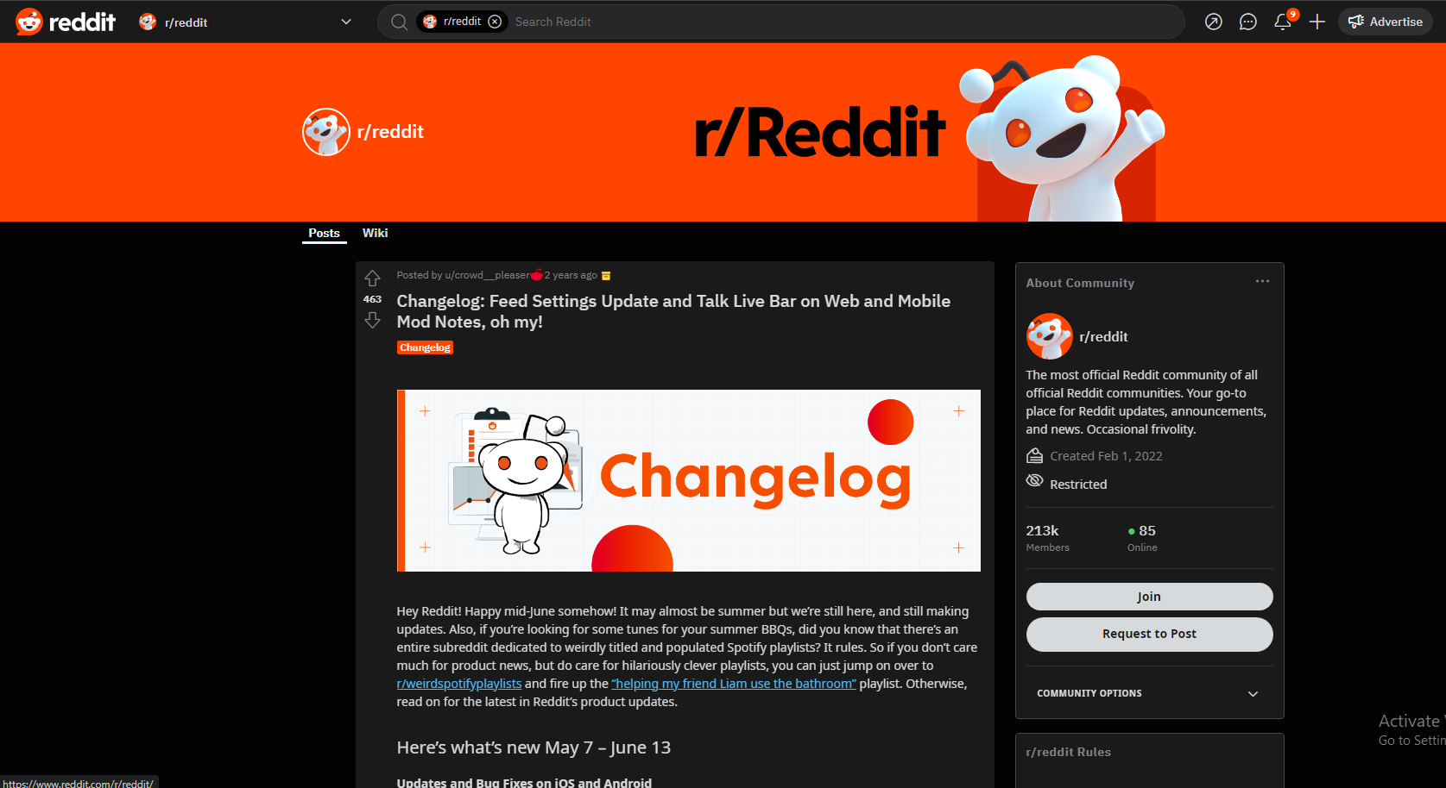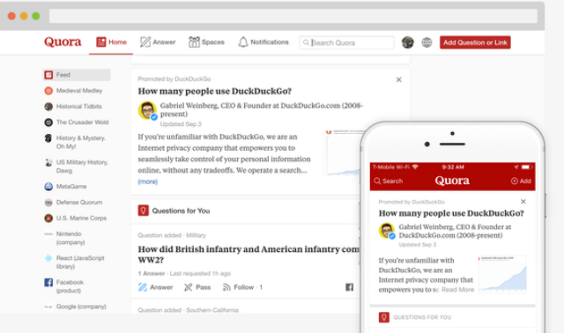

These images are of Reddit and Quora. We aim to design our application to resemble a forum interface similar to these popular websites. As you can see, the interface is very clean and simple, yet, contains multiple features that maximize the user’s experience.

**References (image sources)**

**Reddit image -** Taken as a screenshot from a group members device

**Quora image -** Wikipedia contributors. (2024, January 16 *last edited*). *Quora*. Wikipedia. https://en.wikipedia.org/wiki/Quora